Chapter 5, Solution 10.

Since no current enters the op amp, the voltage at the input of the op amp is v_{s}. Hence

v_{s} = v_{o} 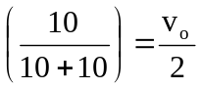 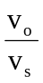 = 2

